|  |  |
| --- | --- |
| Methods of Adding and Deleting Elements | |
| **Methods** | **Description** |
| **Parent-element.createElement(element)** | Create an HTML element. |
| **Parent-element.createComment(‘comment’)** | Create comment. |
| **Parent-element.removeChild(element)** | Remove an HTML element from the parent. |
| **Parent-element.appendChild(element)** | Append an HTML element ***directly before the Ending tag*** of the parent element. |
| **Parent-element.insertBefore(interested child, position)** | Append an HTML element ***in a specific position*** inside the parent element. |
| **document.replaceChild(newchild, old child)** | Replace an HTML element. |
| **document.write(text)** | Write into the HTML **output** stream. |

**Methods of Adding and Deleting Elements**

**Example:** on creating, appending, and insert before child.

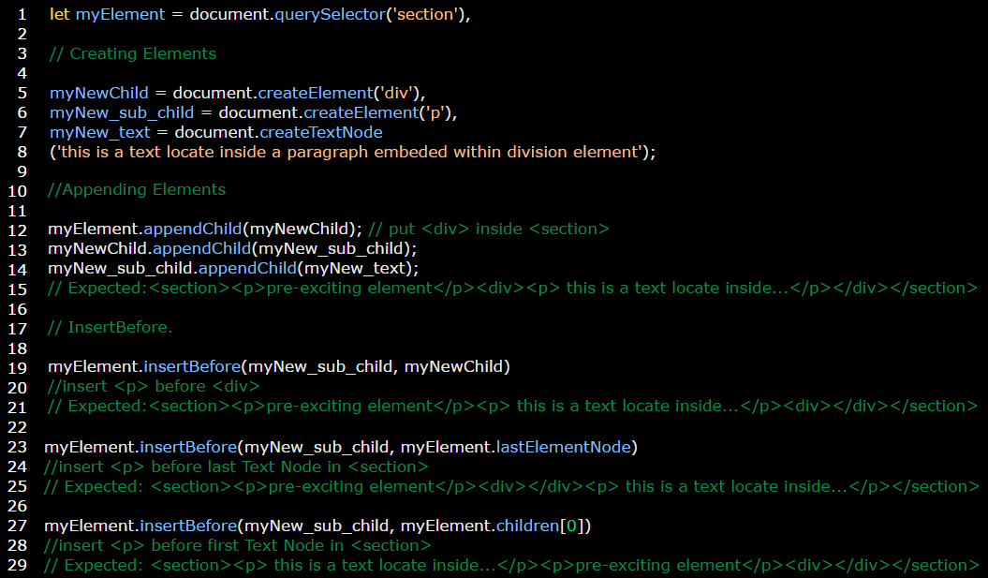

**Example:** on replacing and removing child.

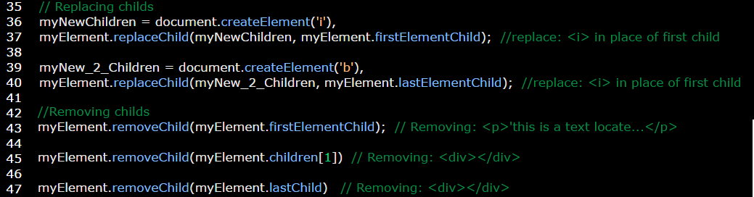

**Example:** on create comment.

